  - 50Days-coding-challenge
  - Day-1[EXCEL]
  - Data cleaning:
  - 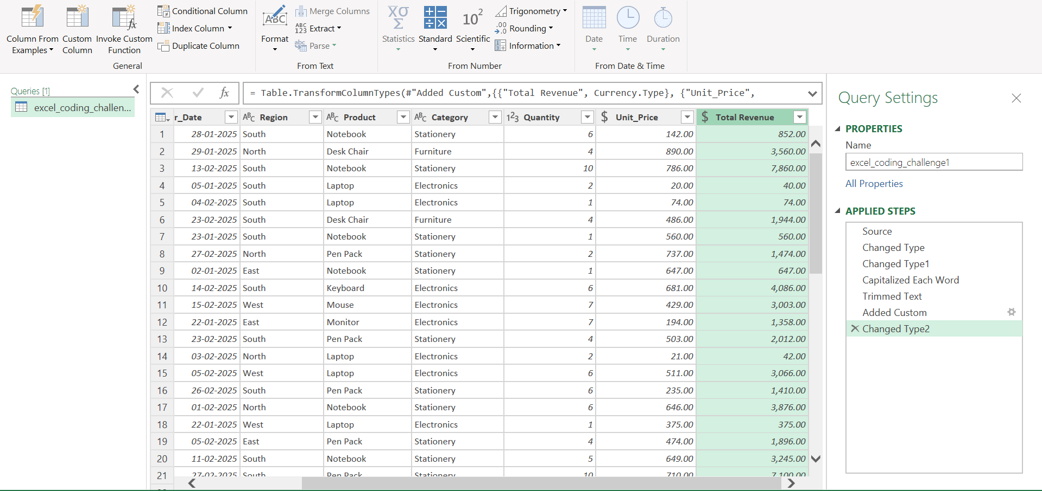

Output
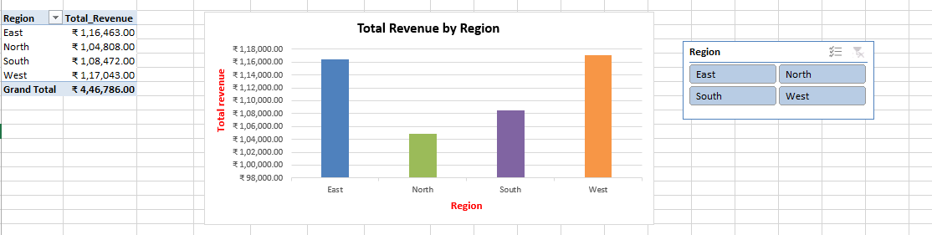
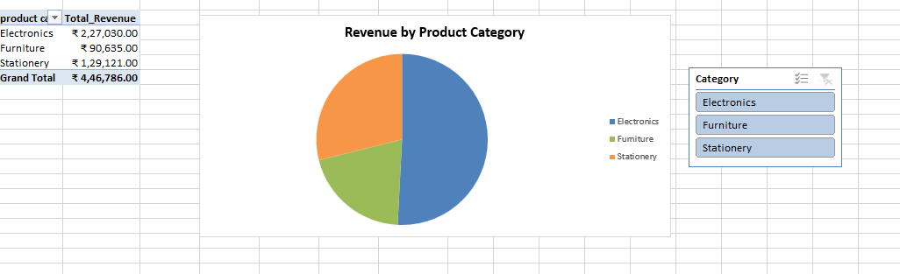
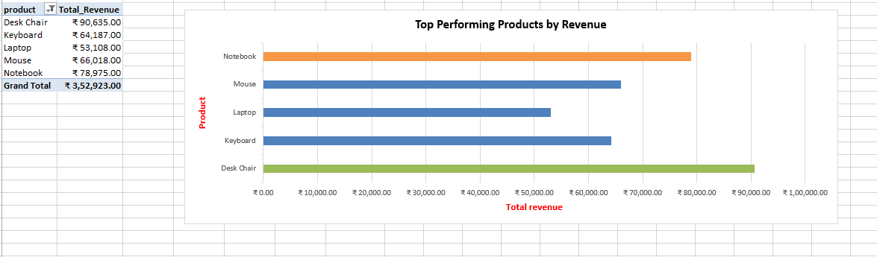
Dashboard output:

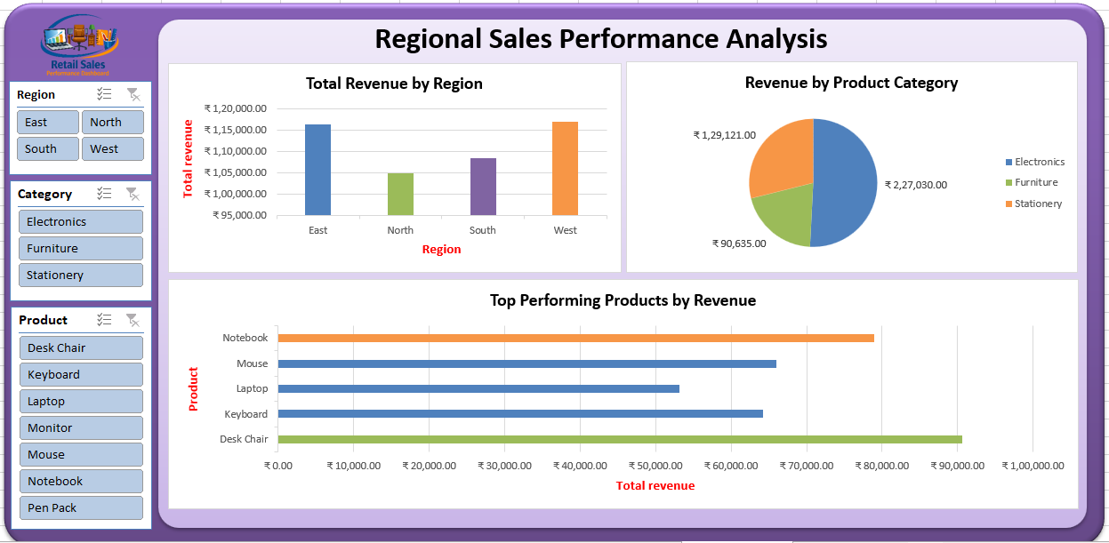

Insight:
- The West region generated the highest revenue, indicating strong sales performance in that region.
- Electronics is the top-performing product category, contributing the largest share of total revenue.
- Furniture generated the lowest revenue among the categories.
- The Top 5 products account for a significant portion of total sales, showing that a few products drive most of the revenue.
- Increasing focus on high-demand products and improving sales in lower-performing regions could help boost overall revenue.

